Aquila District Cub Scout Twilight Camp Sherry Dieckmann, Camp Director
3435 Link:wood Drive
Houston, Texas 77025
713-302-5399 Cell

April 11, 2016

Charles McClelland Chief of Police 1200 Travis
Houston, TX 77002-6000 Dear Chief McClelland:
As we prepare for our 2016 Cub Scout Twilight Camp for the Aquila District, we'd like to ask for your cooperation in the form of emergency assistance to handle any situations we cannot handle at camp.

Twilight Camp will be held at Longfellow Elementary School at 3617 Norris as well as the parking lots, gym and Scout house of Bethany United Methodist Church at 3511 Link:wood. Our Twilight Camp will operate from the hours of 5:30 pm to 9:30 pm weekdays from June 6st through 10th.

In order to meet national standards, we are required to communicate our emergency needs to local responder agencies. We respectfully request a confirmation letter or email acknowledging that the police department is aware of our camp, in order that we might again meet this mandatory requirement specified by the Boy Scouts of America's National Camp Accreditation Program for Cub Scout Day Camps.

We would greatly appreciate it if you could please send the letter at your earliest convenience to my address, 3435 Linkwood Drive, Houston, Texas 77025 or emailing sedieckmann@gmail.com, confirming your services. We will follow security procedures established as required by the BSA in the event of an emergency situation. In the event of an emergency which cannot be handled by the Twilight Camp staff, the staff will call 911 to request assistance.
We can be reached at your convenience at the numbers listed below. Thank you in advance for your assistance and service to the youth of our community.

Sincerely,
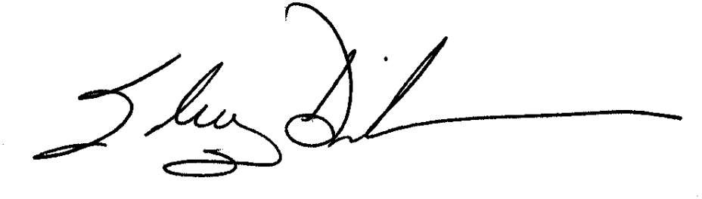
Sherry Dieckmann, 713-302-5399 (cell) Camp Directors
Aquila District Twilight Camp

